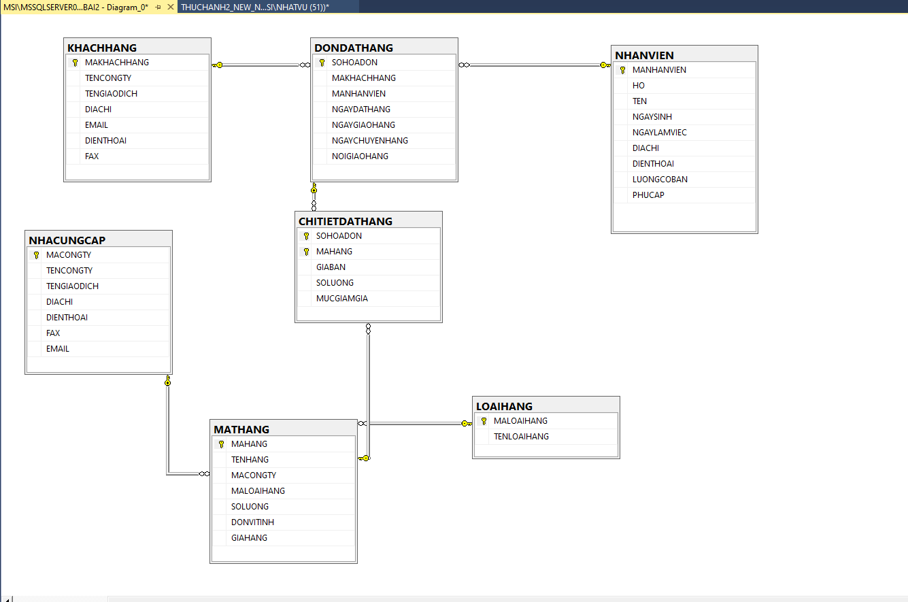

Câu 4

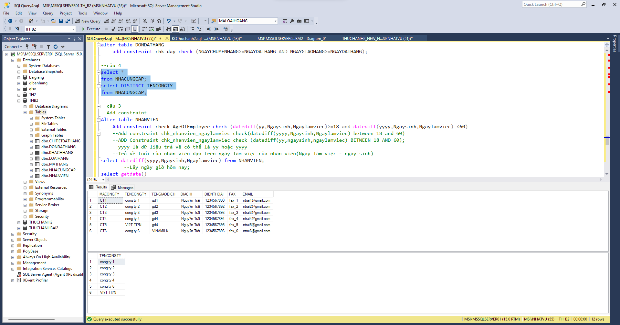

Câu 5

Câu 6

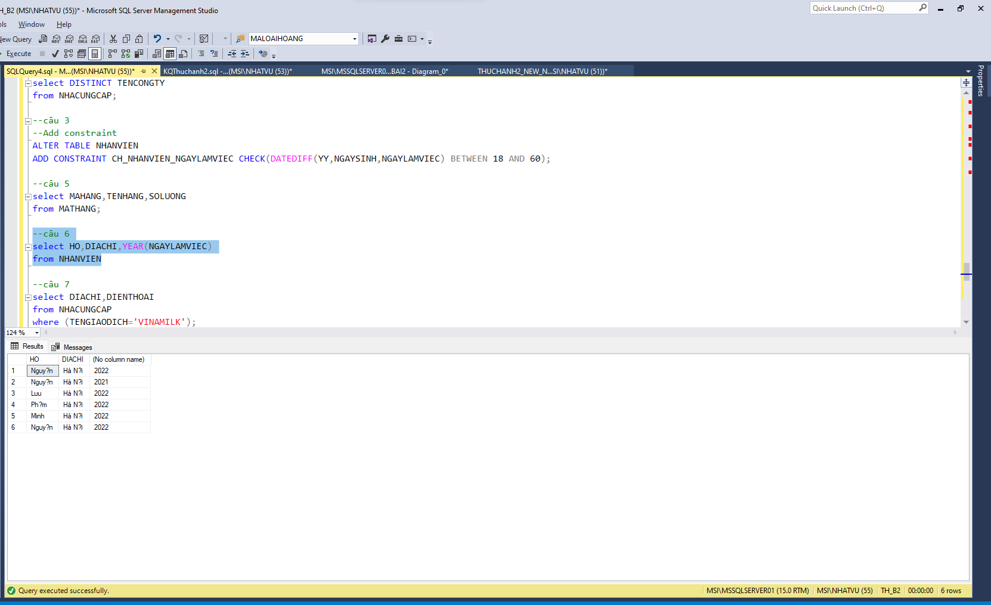

Câu 7

Câu 8

Câu 9

Câu 10

Câu 12:

Câu 13

Câu 14:

Câu 16

Câu 17

**Câu 18**

Câu 20

Câu 21

